SPJMIR
COURAGE AND HEART – Brave and emphatic in the G2 interviews.
COURAGE (Independent thinking) - against the status quo because you have the right reasons.
Heart(empathy) – Understand things from others perspective, looks at things from others perspective.
Bring the stakeholder approach, think from others point of views.
NO Contradiction in the interview.
Story building around whatever claims you make.
AGREED THAT ON PAPER IT SEEMS LIKE I DO NOT HAVE GOOD EXPEIRNCE, BUT WITH THE KIND OF INTERSHIPS THAT I HAVE IN DIEVERSE FILEDS, WITH THE KIND OF EXPEIRNCE THAT I BRING TO THE TABLE, AND THE KIND OF LEARNING MENTALITY THAT I BRING TO THE TABLE, I REALLY BELIEVE THAT I DESERVE THIS SEAT.
Academics : Drive the interview towards your strengths.

POINTS ABOUT SPJMIR
2 group interviews:
Group interview 1 – 4-5 interviews in each panel. Process of rejection.
Shortlisted interviews go for Group interview 2.
Results are announced in the month of march.

Things about form
Understand key personality traits about you.
Question in the form will be mentioned in the form
OVERALL GUIDELINES
Do not fake a personality trait/incident.
You may dramatize the event a bit, for example might increase the weightage.
AVIOD CLICHÉ in the forms, common answers.
Narrating an incident in the answer, follow the STAR approach
- S – Describe the situation
- T- Task at hand, what you are supposed to do
- A – Action taken
- R – Results that followed
NO SKIPPING ANSWERS TO ANY QUESTION
Smart quirky things – If you have the confidence to carry that in the interview. If you are not quirky, avoid this, but if you are quirky, go ahead and put it.
Can mention hobbies, passion.
You beliefs : I believe in equal opportunity for women.
Your habits : I am an early riser. Do my best creative work late at night.
Your life goal/desires/fears (NOT your career goals): I aspire to do a backpacking world tour

Q2. State one experience of your formative years (up to 18 years of age) and explain how it helped to shape your personality. (150 words)
TURNING POINT OF YOUR LIFE.
Expeirence 1: Disciple of being an army kid and how it shaped my personality. Like living in multiple places all over the country.
I have the ability to not only adapt to any place, but also the ability to stand out in a new place because of my experience in moving all across the country.
Experience 2 : How my father had to take over the marriage and his journey from sipahi to commissioned officer.

z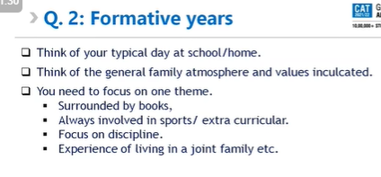
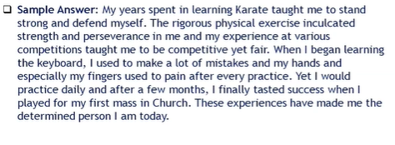

Q3. Describe an experience where you got an opportunity to either showcase courage or compassion and how it impacted you. (150 words)
STAR – Can skip the TASK here.
Engaging in NGO, going to teach and social works.
Describe the impact it had on you.
Helping maid in the term of Covid.
Story 1 : Only student to get selected in the basketball team in class 9 and make a space for myself in the playing five of the team.
Story 2: The first person from PCM to get the sports captain in class 12th even though I joined he school an year back at the time of selection.

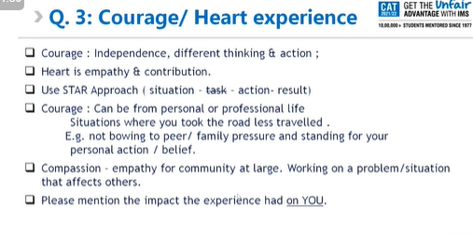

Q4. Were you a part of any team, which did not achieve its desired goals? what were your learnings from the experience? (150 words)
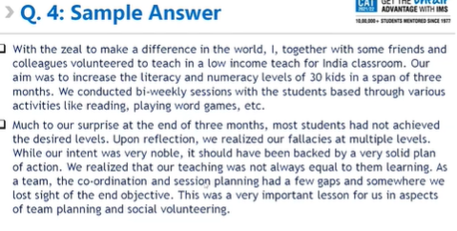
STAR approach
TRIED SOMETHING – IT DID NOT GO WELL – AFTER THAT WHAT DID YOU DO TO THAT TO AVOID IT
DONTS..
- Not my fault
- Will form a better team.
- Part of recent experience?
(This is heavy weightage) - This is definitely the basketball team loss in class 11th.
Can show how we failed to get number in Finlatics?
Q5. Describe a situation in which you believed a certain approach was morally right, but your point of view was in conflict with other viewpoints. how did you handle this dilemma? (150 words)
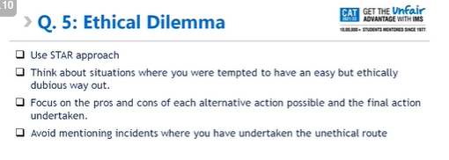
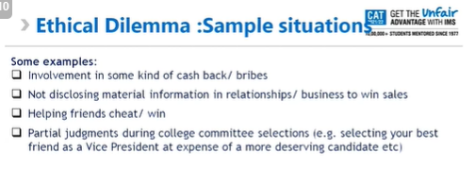
Moral conflict with others.
STAR – S – becomes the hero in this answer.
Shows the incident as authentic.
- Left the work at Finlatics people to avoid unethical sales. Research more on this topic of unethical sales.
- Or left it to avoid unethical data share of the students. I have the problem of sharing the data without informing the customers and in a way I felt responsible. So I had to part my ways.
1. Can answer the option where a senior was asking me to say this is done, but I did not like it. . A senior was helping me to say that that project was not our fault, and it was in pipeline because of some other team but in reality we did not inform the team to put in the project. When we the call with the business we decided to put the blame on the team. I was against it, and completed the project late at night to deliver the project.
2. Keeping online from the phone and not working on the laptop to avoid taking leaves in the office.

Q6. Describe a person you would like (or not like) to work with (or live with) and why? (100 words)
ANS: Should be paragraph format.
I like to be a person who is passionate towards art, any kind of art. Music, books, painting, anything, as long as you can talk hours on that. Should have a long term passionate goal in life, and the focus should be in contributing to the society in the long run. They should have a sense of humor about life in general and have a good heart.
WHAT MAKES YOU HAPPY IN YOUR TIME?
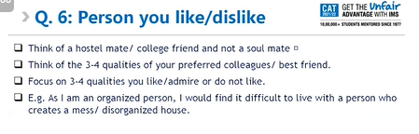

SPJMIR GI Prep
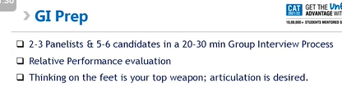
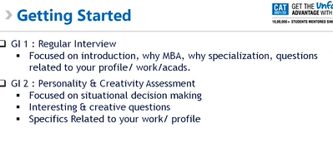
G1 : Regular interview:
Tell me about yourself.
Tell me 3 things about yourself.
Tell me one thing that is not on your form.
WHY MBA? – Need to have a kadak answer for this
WHY SPECIALIZATION? – Need to have a kadak answer for this
IF THESE ANSWERS ARE SHAKY THEN VERY DIFFICULT TO GO TO GROUP INTERVIEW 2.
Speak only when you are supposed to speak. Listen very carefully what others are speaking, because you are supposed to listen.
Fundamentals of ACADS is important.

G2: Situation decision making.
Personal interview happening in group format for relative assessment.

